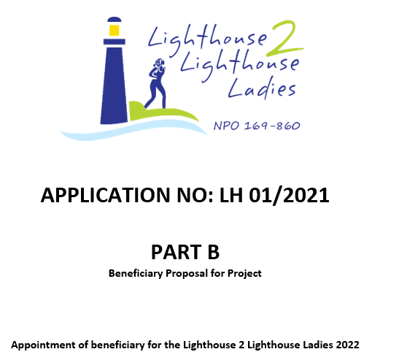

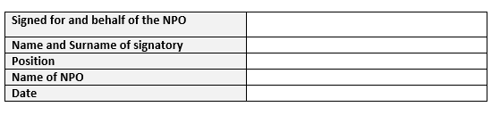
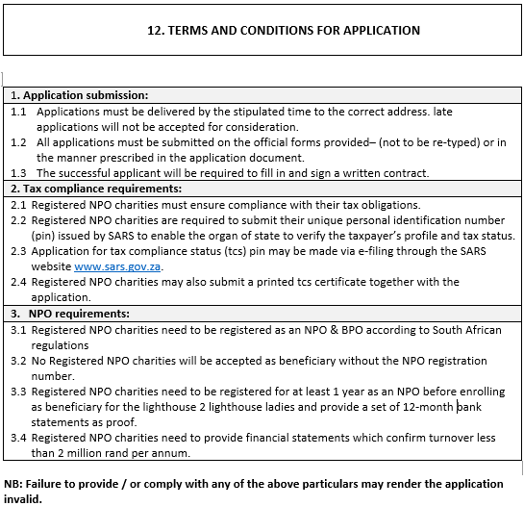

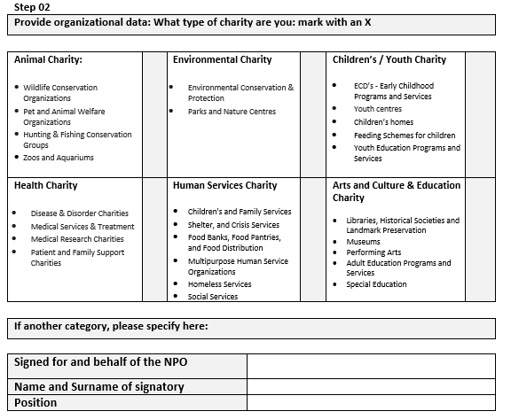
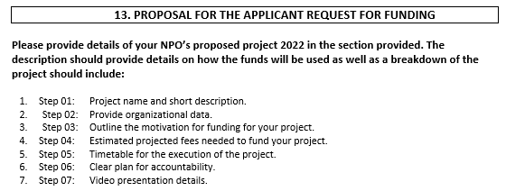

Step 01
Your project name:
In 50 words or less provide a short description of the proposed project for which funding is needed

Step 03

Outline the motivation for funding for your project in 5 sentences or less below
Describe and define your charity’s need below. Also indicate community/group that will benefit from this project as a whole. Use the example below to guide you.
Example 01:
Existing Educational Centre to be repainted and re-roofed for ECD center.

Example 02:
New vehicle needed to transport the elderly of old age home to and from their doctors appointments and to take them shopping during the week.

Your motivation:

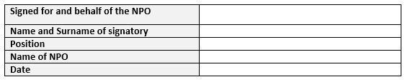

Step 04

Estimated funds needed for your project
Include breakdown of cost estimate below needed to complete your project. Use the example below to guide you.
Example 01:
Existing educational centre to be repainted and re-roofed for ECD center.

Painting supplies R 1 200.00
Paint needed 10 x 20 Litre buckets at R 900 per bucket R 9 000.00
Labour – 20 days at R 550 per day R 11 000.00
Transport of material to and from shop R 900.00
Dropsheets, brushes, buckets R 4 000.00
New ladder x 2 at R 2300 per ladder R 4 600.00
Total R 30 700.00

Example 02:
New vehicle needed to transport the elderly of old age home to and from their doctors appointments and to take them shopping during the week.

Model type of vehicle/bus Single Decker bus
Make of vehicle 2015 Nissan 15 seater bus
Fuel type Diesel
Estimated purchase price second hand R 220 000.00
Total R 220 000.00

Insert your estimated projected fees needed to fund your project below:

Step 05
Timetable for the execution of the project
Outline of the activities / plan of action to make this happen with dates
Example 01:
Existing Educational Centre to be repainted and re-roofed for ECD center.

01 June: Book painting contractor
04 June: Order and pay for painting supplies and materials
05 June: Paintwork begins with repairing of walls
10 June: Painting of exterior walls begin
20 June: Completion of exterior walls and interior walls begin
30 June: Completion of project and make appointment for Lighthouse 2 Lighthouse
committee to come and view school and take photos.

Example 02:
New vehicle needed to transport the elderly of old age home to and from their doctors appointments and to take them shopping during the week.

01 June: Do research for best possible vehicle
14 June: Identify vehicle to purchase
16 June: Vehicle to be registered in charity’s name
20 June: Completion of project and make appointment for Lighthouse 2 Lighthouse
committee to come and view school and take photos.

Insert your estimated timetable for execution of the project below:

Full name of the person responsible for overseeing this project?
Telephone number
Email address
